**PROJECT – SHOPFAST ECOMMERCE SQL ANALYSIS SCENARIO**

📅 – 02nd June 2025

DB CREATION

CREATE DATABASE ShopFast;

GO

USE ShopFast;

CSV File Import

Imported tables in MSSQL Server

SELECT * FROM CUSTOMERS;

SELECT * FROM ORDERS;

SELECT * FROM PRODUCTS;

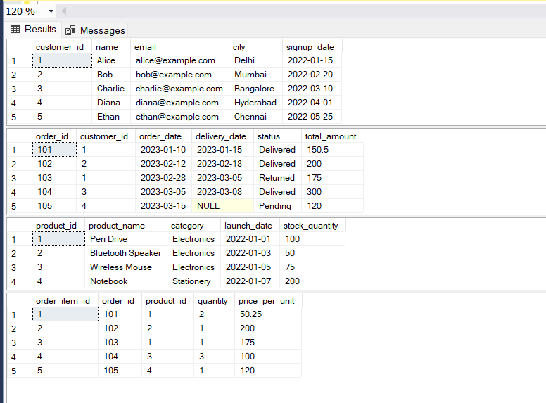SELECT * FROM ORDER_ITEMS;

SQL QUERIES FOR PROBLEM SET

--1. Customer Sign-up Trend: New customers per month (last 12 months)

SELECT FORMAT(signup_date, 'yyyy-MM') AS month, COUNT(*) AS new_customers

FROM CUSTOMERS

WHERE signup_date >= DATEADD(MONTH, -12, year(2023)) --getdate()

GROUP BY FORMAT(signup_date, 'yyyy-MM')

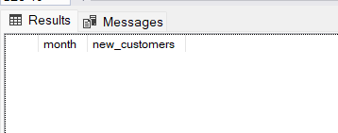ORDER BY month;

Output 1 – With 2023 Year Output 2 – With GETDATE() Curretnt year 2025

--2. Top 5 Customers by Revenue

SELECT TOP 5 c.customer_id, c.name, COUNT(o.order_id) AS total_orders,

SUM(o.total_amount) AS total_revenue,

AVG(o.total_amount) AS avg_order_value

FROM CUSTOMERS c

JOIN ORDERS o ON c.customer_id = o.customer_id

GROUP BY c.customer_id, c.name

ORDER BY total_revenue DESC;

Output -

--3. Order Status Distribution

SELECT status, COUNT(*) AS order_count

FROM ORDERS

GROUP BY status;

Ouput –

--4. Revenue by Category

SELECT p.category, SUM(oi.quantity * oi.price_per_unit) AS total_revenue

FROM ORDER_ITEMS oi

JOIN PRODUCTS p ON oi.product_id = p.product_id

GROUP BY p.category

ORDER BY total_revenue DESC;

Output –

--5. Best-Selling Products (Top 5 by quantity sold)

SELECT TOP 5 p.product_name, SUM(oi.quantity) AS total_sold

FROM ORDER_ITEMS oi

JOIN PRODUCTS p ON oi.product_id = p.product_id

GROUP BY p.product_name

ORDER BY total_sold DESC;

Output –

--6. Low-Stock Products (<10% stock using CASE)

SELECT product_id, product_name, stock_quantity,

CASE

WHEN stock_quantity < 10 THEN 'Critical Low'

WHEN stock_quantity BETWEEN 10 AND 50 THEN 'Low'

ELSE 'Sufficient'

END AS stock_status

FROM PRODUCTS;

Output –

--7. Avg Delivery Time per Month

SELECT FORMAT(order_date, 'yyyy-MM') AS order_month,

AVG(DATEDIFF(DAY, order_date, delivery_date)) AS avg_delivery_days

FROM ORDERS

WHERE delivery_date IS NOT NULL

GROUP BY FORMAT(order_date, 'yyyy-MM')

ORDER BY order_month;

Output –

--8. Orders with Delivery >7 days

SELECT *

FROM ORDERS

WHERE DATEDIFF(DAY, order_date, delivery_date) > 7;

Output (No orders with 7 days date difference)-

--9. Repeat Customers

SELECT customer_id, COUNT(*) AS order_count

FROM ORDERS

GROUP BY customer_id

HAVING COUNT(*) > 1;

Output –

--10. Monthly Revenue Growth with LAG()

WITH MonthlyRevenue AS (

SELECT FORMAT(order_date, 'yyyy-MM') AS order_month,

SUM(total_amount) AS revenue

FROM ORDERS

GROUP BY FORMAT(order_date, 'yyyy-MM')

)

SELECT order_month, revenue,

revenue - LAG(revenue) OVER (ORDER BY order_month) AS revenue_growth

FROM MonthlyRevenue;

Output –

--11. Cohort Analysis using CTE (signup year)

WITH Cohorts AS (

SELECT customer_id, YEAR(signup_date) AS signup_year

FROM CUSTOMERS

)

SELECT c.signup_year, COUNT(o.order_id) AS total_orders

FROM Cohorts c

JOIN ORDERS o ON c.customer_id = o.customer_id

GROUP BY c.signup_year;

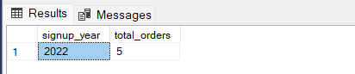Output –

--12. Cancelled/Returned Product Revenue Loss

SELECT status, SUM(total_amount) AS revenue_loss

FROM ORDERS

WHERE status IN ('Cancelled', 'Returned')

GROUP BY status;

Output –

--13. Customer City Heatmap

SELECT city, COUNT(*) AS customer_count

FROM CUSTOMERS

GROUP BY city

ORDER BY customer_count DESC;

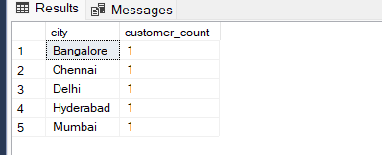Output –

--14. First & Last Order per Customer using ROW_NUMBER()

WITH OrderedData AS (

SELECT customer_id, order_id, order_date,

ROW_NUMBER() OVER (PARTITION BY customer_id ORDER BY order_date ASC) AS rn_asc,

ROW_NUMBER() OVER (PARTITION BY customer_id ORDER BY order_date DESC) AS rn_desc

FROM ORDERS

)

SELECT customer_id, order_id, order_date, 'First Order' AS order_type

FROM OrderedData WHERE rn_asc = 1

UNION ALL

SELECT customer_id, order_id, order_date, 'Last Order' AS order_type

FROM OrderedData WHERE rn_desc = 1

ORDER BY customer_id, order_type;

Output –

-- 15. NULL Handling: Orders with missing delivery date or total amount

SELECT order_id, customer_id, order_date, delivery_date, total_amount,

CASE WHEN delivery_date IS NULL THEN 'Missing Delivery Date' ELSE '' END AS delivery_issue,

CASE WHEN total_amount IS NULL THEN 'Missing Amount' ELSE '' END AS amount_issue

FROM ORDERS

WHERE delivery_date IS NULL OR total_amount IS NULL;

Output –

